If you are submitting the final paper, you could refer the following steps.
1.fisrt ,login in and enter the easychair
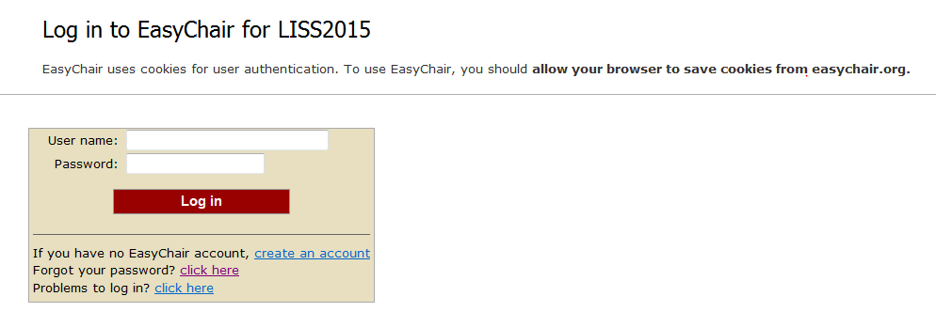
2.click the”submission” ,your will open a new desktop,and the click the “add or update a file (update a file)”
Pay attention to the red words.
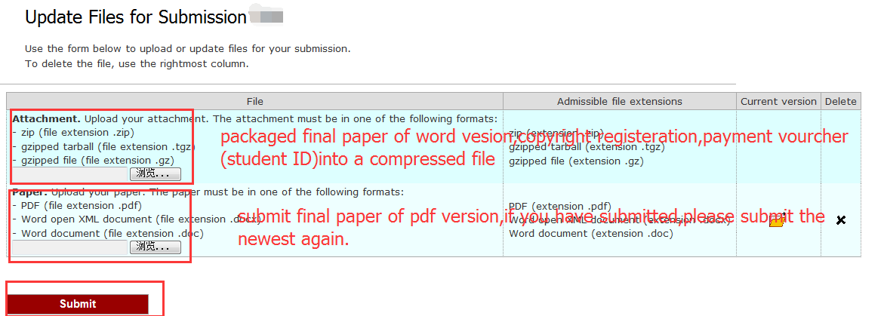
3.click the “submit”,and you have finished the process.
