Alumni House, D-5 | Greenhouse, A-7 | Pacific Film Archive (PFA) Theater, D-4
Andersen Auditorium (Haas School of Business), C-2 | Grinnell Natural Area, C-6 | Parking Lots/Structures, A-3, A-4/5, D-3, D/E-6,
Anthony Hall, C/D-4 | Haas Pavilion, D-5 | E-4, E/F-3, E/F-5/6
Architects and Engineers (A&E), D-4 | Haas School of Business, C-2 | Pimentel Hall, B-3
Bancroft Library, C-4 | Hargrove Music Library, D-3 | Pitzer Auditorium (Latimer Hall), C-2/3
Banway Bldg., D-7 | Haste Street Child Development Center, F-5 | Police, UC (Sproul Hall), D-4
Barker Hall, A/B-6 | Haviland Hall, B-4/5 | Recreational Sports Facility, D-5/6
Barrow Lane, D-4 | Hazardous Materials Facility, C/D-6 | Residence Halls
Barrows Hall, D-4 | Hearst Field Annex, D-4 | Bowles Hall, C-2
BART Station, C-7 | Hearst Greek Theatre, B-2 | Clark Kerr Campus, F-1
Bechtel Engineering Center, B-3/4 | Hearst Memorial Gymnasium, D-3 | Cleary Hall, E/F-4/5
Berkeley Art Museum (Woo Hon Fai Hall), D/E-3 | Hearst Memorial Mining Bldg., B-3 | Foothill Residence Halls, A/B-2/3
Birge Hall, C-3 | Hearst Mining Circle, B-3 | Ida Louise Jackson Graduate House, E-2/3
Blum Hall, A/B-4 | Hearst Museum of Anthropology, D-3 | Martinez Commons E/F-4
Boalt Hall, D-2 | Heating Plant, Central, C-6 | Stern Hall, B-2/3
Botanical Garden, C-1 | Hellman Tennis Complex, C-6 | Unit 1, E-3
Brain Imaging Center, B-5 | Hertz Hall, C/D-3 | Unit 2, F-3
C.V. Starr East Asian Library, B-4 | Hesse Hall, B-4 | Unit 3, E-5
California Hall, C-4 | Hewlett-Packard Auditorium (Soda Hall), A-3/4 | Residential and Student Services Bldg., E-3
California Memorial Stadium, D-1 | Hildebrand Hall, C-3 | Sather Gate, D-4
Calvin Laboratory, D-2 | Hilgard Hall, B-5 | Sather Rd., C-4
Campanile (Sather Tower), C-3 | Insectary, A-7 | Sather Tower (Campanile), C-3/4
Campbell Hall, B/C-3/4 | International House, D-2 | Senior Hall, C-3
Career Center, D/E-5 | Ishi Court, C-5 | Sibley Auditorium (Bechtel Engineering
Chan Shun Auditorium | Jones Child Study Center, E-6 | Center), B-4
(Valley Life Sciences Bldg.), C-5 | Kleeberger Field House, D-6 | Silver Space Sciences Laboratory, C-1
Chávez Student Center, D-4 | Koshland Hall, A/B-6 | Simon Hall, D-2
Cheit Hall, C-2 | Kroeber Hall, D-3 | Simpson Center, C/D-1/2
Clark Kerr Campus, F-1 | Krutch Theater, F-2 | Soda Hall, A-3/4
Class of 1914 Fountain, D-3 | Latimer Hall, B/C-3 | South Hall, C-4
CNMAT, A-5/6 | Lawrence Berkeley National Laboratory, B-2 | Spieker Aquatics Complex, D-5
Cory Hall, A/B-3 | Lawrence Hall of Science, C-1 | Spieker Plaza, D-5
Cyclotron Rd., B-2 | LeConte Hall, C-3 | Springer Gateway, C-6
Davis Hall, B-3/4 | Levine-Fricke Field, C-1 | Sproul Hall, D-4
Doe Memorial Library, C-4 | Lewis Hall, C-2/3 | Sproul Plaza, D-4
Donner Lab, B-3 | Life Sciences Addition, C-5 | Stadium Rim Way, C-1/2
Durant Hall, C-4 | Lower Sproul Plaza, D-4/5 | Stanley Hall, B-3
Durham Studio Theatre (Dwinelle Hall), C-5 | Martin Luther King Jr. Student Union, D/E-4 | Stephens Hall, C-3/4
Dwinelle Annex, C/D-5 | Mathematical Sciences Research Institute, C-1 | Strawberry Canyon Recreation Area, C-1
Dwinelle Hall, C-4/5 | Maxwell Family Field, C-2 | Sutardja Dai Hall, A/B-3/4
East Gate, B-3 | McCone Hall, B-4 | Tan Hall, B/C-3
Edwards Stadium, D-6 | McEnerney Hall, A-5/6 | Tang Center, E/E-6
Energy Biosciences Building A/B-6/7 | McLaughlin Hall, B-4 | Tolman Hall, A/B-5
Eshleman Hall, D-4/5 | Memorial Glade and Pool, B-4 | UC Berkeley Extension, B-7
Etcheverry Hall, A-4 | Minor Hall, C-2/3 | Underhill Playing Field, E-3
Evans Diamond, D-6 | Minor Hall Addition, C-3 | University Dr., B-5
Evans Hall, B-3 | Moffitt Undergraduate Library, B/C-4 | University Hall, B-6
Eye Center (Minor Hall Addition), C/D-3 | Morgan Hall, B-5/6 | University Health Services, D/E-6
Eye Center (Tang Center), D/E-6 | Morrison Hall, C/D-3 | University House, A/B-5
Faculty Club, C-3 | Moses Hall, C-4 | University of California Press (UC Press), B-7
Faculty Glade, C-3 | Mulford Hall, B-6 | Valley Life Sciences Bldg., C-5
Founders’ Rock, A/B-3 | Natural Resources Laboratory, A-6 | Visitor Center (Sproul Hall), D/E-4
Fox Cottage, E-3 | North Field, D-3 | Warren Hall, A-6/7
Frank Schlessinger Way, C-6 | North Gate, A/B-4 | Wellman Hall, B-5
Gayley Rd., B/C-2 | North Gate Hall, A-4 | West Circle, B/C-5/6
Genetics and Plant Biology Bldg., B-6 | Northwest Animal Facility, A/B-6 | West Gate, B/C-6
Giannini Hall, B-5 | O’Brien Hall, B-4 | Wheeler Hall, C-4
Giauque Hall, C-3 | Observatory Hill, B-4 | Wickson Natural Area, B-5
Gilman Hall, C-3 | Old Art Gallery, C/D-4 | Witter Field, C-1
Girton Hall, C-2 | Optometry Clinic (Eye Center, | Women’s Faculty Club, C-3
Golden Bear Recreation Center, F-2 | Minor Hall Addition), C-3 | Wurster Hall, D-2/3
Goldman Field, D-6 | Optometry Clinic (Eye Center,Tang Center), D/E-6 | Zellerbach Hall, D-5
Goldman Plaza D-1/2 | Oxford Research Unit, A-6/7 | Zellerbach Playhouse, D-5
Goldman School of Public Policy, A-3 | Pacific Film Archive (PFA) (Woo Hon Fai Hall), D/E-3

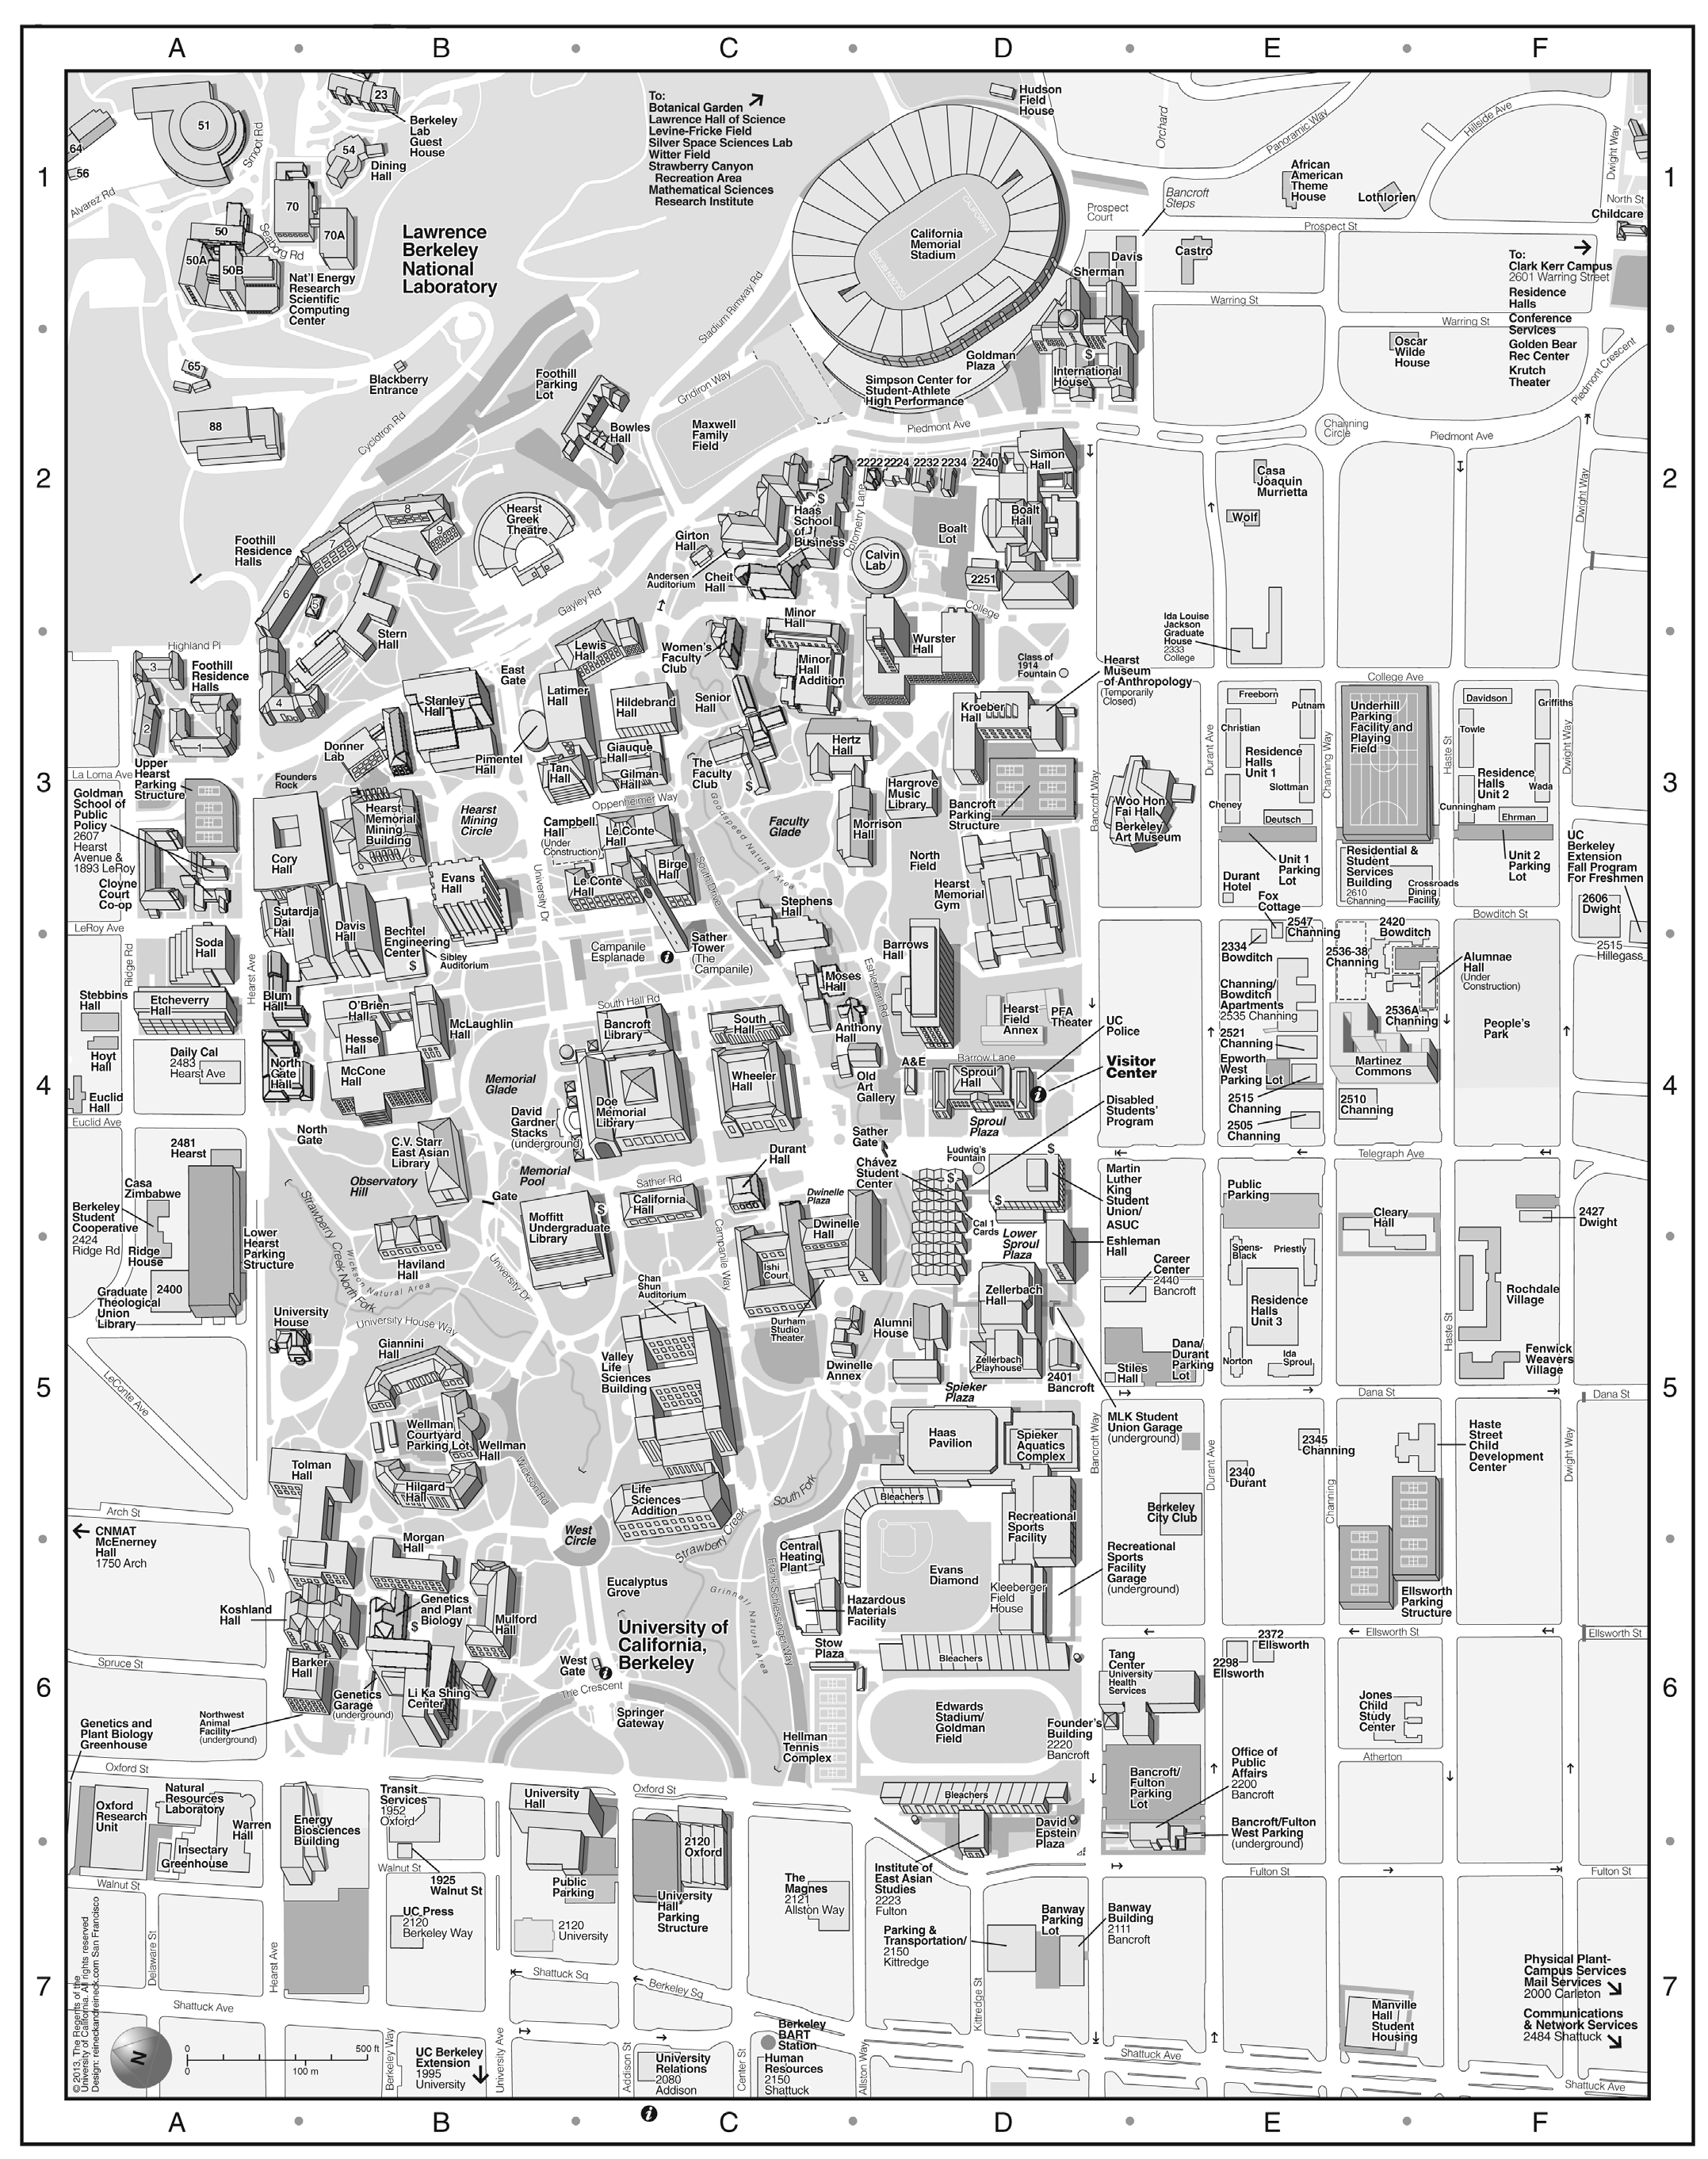
A: Etcheverry hall
(Conference building)
B: Faculty club
(July 24th dinner)
C: Memorial Glade
(Group photo)
D: Sather Gate
E: West side
E
D
C
B
A
Produced by the Office of Public Affairs 13065 0515 © 2013 Regents of the University of California

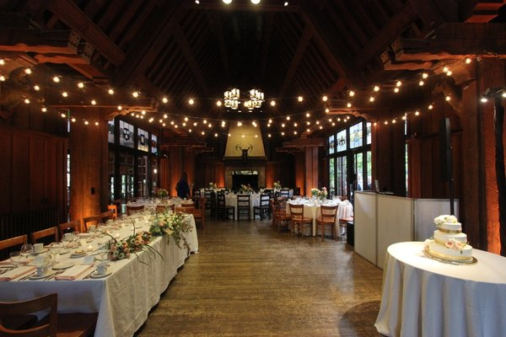
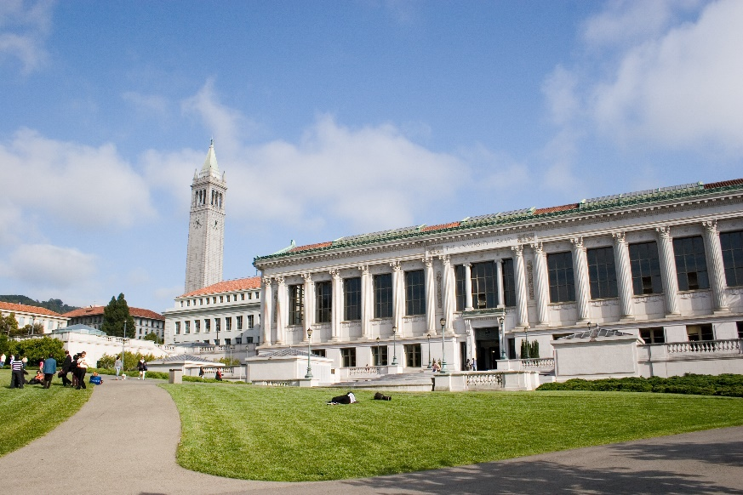
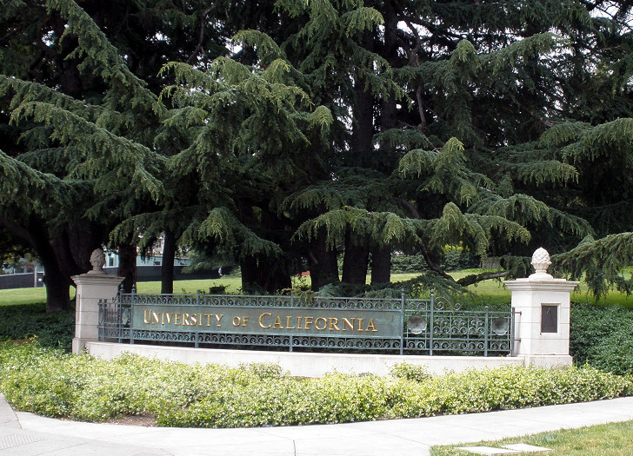
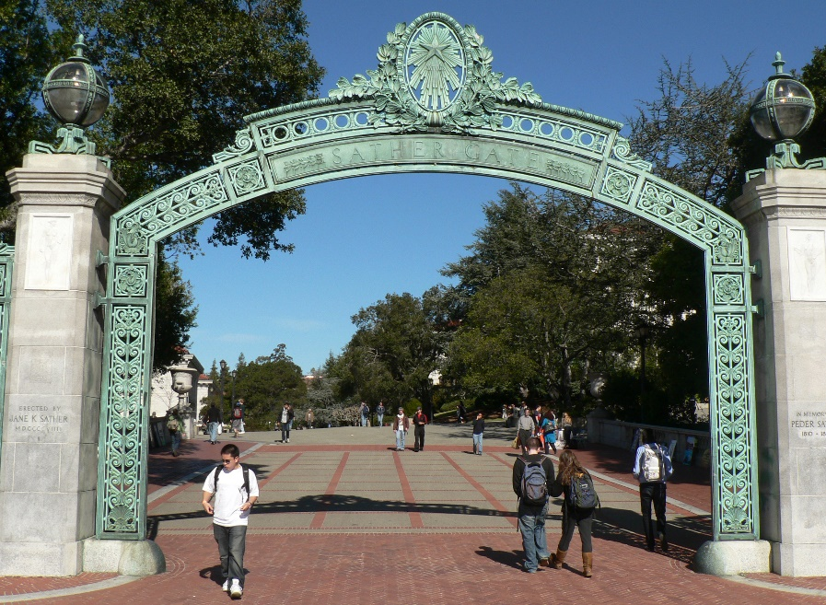
E: West side
B: Faculty club
D: Sather Gate
C: Memory Glade

